M

|  |  |
| --- | --- |
| Hospital database  **IFSC 3330 Current Trends in Database Technology** | BY  RUKSHAR PARWIN |

Table of Contents

INTRODUCTION2

PHASE_13-4

Database application of Hospital

ER Diagram

PHASE_25

Relation schemas

Identifies the foreign keys

PHASE_36-9

Create and populate database

PHASE_410-12

Application program and results

**INTRODUCTION**

With ever growing need and to address new challenges in patient care, Hospitals have now turned into Healthcare systems with facilities expanding its services in different locations, and multiple facilities coming together to serve the community. As such, the database to support a healthcare system is ever expanding to capture different levels of data related to patient care, research, and analysis.

Most Healthcare system starts with a single facility and limited department and physicians and grow based on community needs. For this project, I am designing a database system to capture the most basic information a hospital might capture. The database design captures Patient Demographic information, admission details including disease and symptoms, Physician information, Department and Hospital information along with the address.

During the first phase of this project, I finalized the data requirements for the application. With simplicity in mind, I decided to focus on Hospital and its patient. For hospital, I expanded to include multiple departments and physician information. For Patient related information, I limited the data capture to include patient’s visits along with capturing basic information such as disease, diagnosis and drugs.

While designing ER diagram during phase 2, I focused on making sure I conform to the principles of normalization form. For example, instead of capturing hospital and the entire related departments in the same table, I stored department as a separate table and included a foreign key to avoid hospital information such as address repetition. Along the same principles, I worked on avoiding redundancy for each data capture and came up with 5 tables including 1) Hospital Information, 2) Patient Information, 3) Department Information, 4) Patient Record, and Physician Information.

For phase 3, I mapped ER schema into a relational schema, capturing all the related Primary and foreign key in each table based on the initial mapping in ER diagram. I then used Oracle instance that is used for class assignments to start creating tables and populated database with few test records.

In the last phase of the project, I wrote queries that will retrieve the data inserted during phase 4. For query designing phase, I made sure to design a problem that will require me to join at least 2 tables. Some of the questions I tried answering with the queries include count of Patients in each Department or zip code of patient who are 18 years or younger.

In the next sections, I have listed details related to each phase with and SQL that were used to create database tables, insert test data and data retrieval.

PHASE_1

## HOSPITAL DATABASE

* The Hospital keep track of each patient’s first name, patient last name, patient number, current address include city, state, zip code, and phone number, birthdate, sex, here patient ID have unique values for each patient.
* Each Hospital has a name, address include city, state, zip code and they have different department like emergency Department, ICU, skin specialist, dentist, ortho, pediatricians, here each Hospital ID (HID) will have a unique value as a primary key.
* Each department is described by a name, department code, office number, office phone, both name and code have unique values for each department.
* Each patient has record of disease, symptoms, diagnosis, drugs, patient history, when they admitted and discharged, what is the name of their physician.
* Each Physician has an ID, name, Specialty, Employment Start date, Degree.

ER DIAGRAM

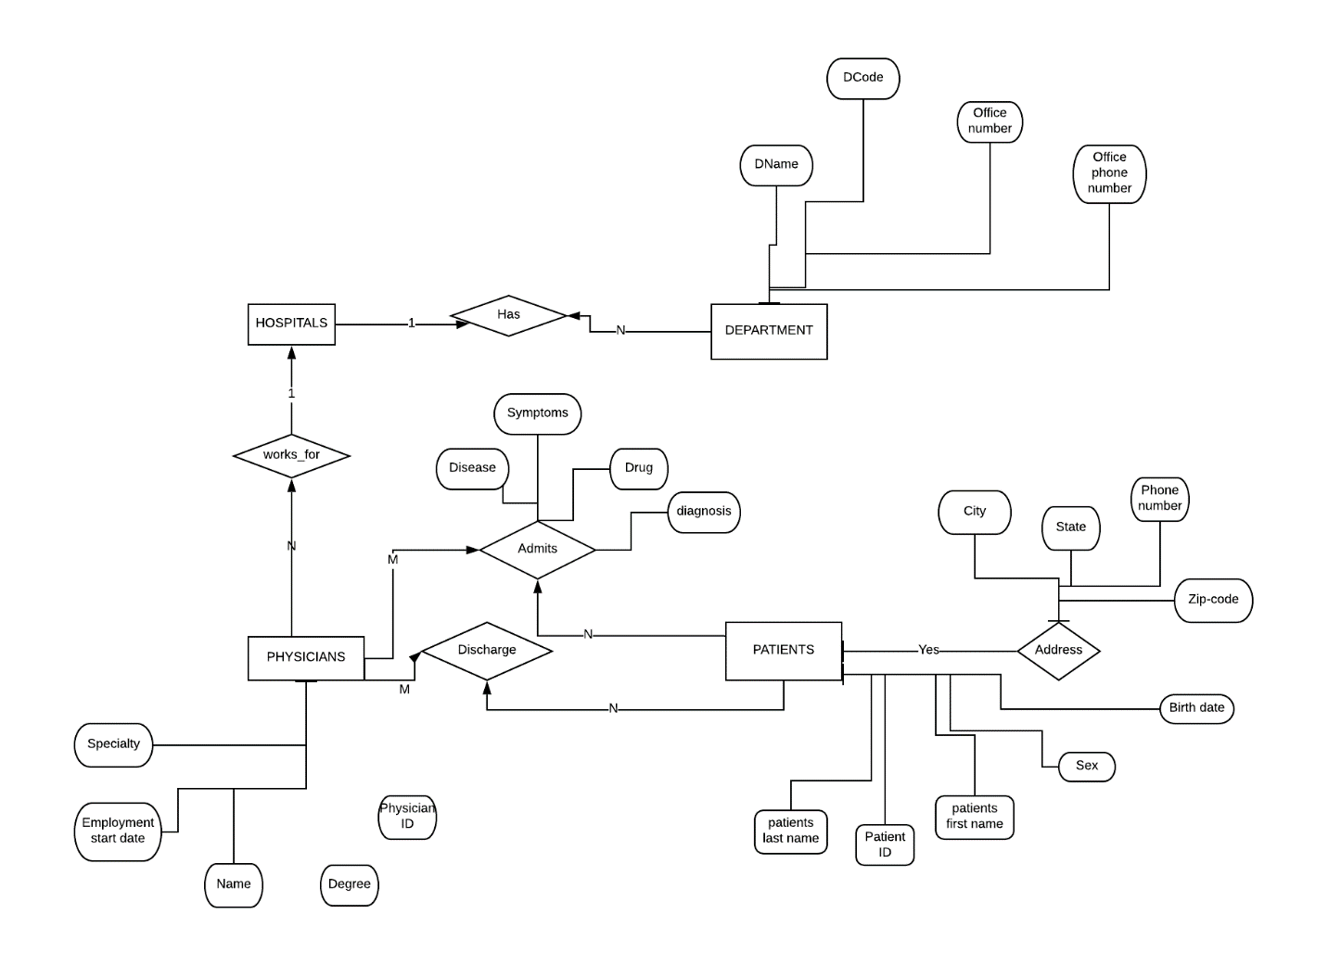

Address

PHASE_2

RELATIONAL SCHEMA

Hospital_info (HID, Hname, Hcity, Hstate, Hzip code)

Patient_info (PID, PFname, PLname, Pnumber, city, state, zip code, phone number, birthdate, sex, DCode)

Department_info (DCode, Dname, office number, office phone, HID)

Patient_record (VisitID, disease, symptoms, diagnosis, drugs, patient history, time of admited, time of discharged, physician_ID, PID)

Physician_info (physician_ID, Physician_name, Specialty, Employment Start date, Degree)

IDENTIFY THE FOREIGN KEYS

Hospital_info (HID, Hname, Hcity, Hstate, Hzip code)

Patient_info (PID, PFname, PLname, Pnumber, city, state, zip code, phone number, birthdate, sex, DCode)

Department_info (DCode, Dname, office number, office phone, HID)

Patient_record (VisitID, disease, symptoms, diagnosis, drugs, patient history, time of admited, time of discharged, physician_ID, PID)

Physician_info (physician_ID, Physician_name, Specialty, Employment Start date, Degree)

(This is in 3NF ) because It is in second normal form and There is no transitive functional dependency.

PHASE_3

Create and populate database

DROP TABLE hospital_info CASCADE CONSTRAINTS;   
  
CREATE TABLE hospital_info   
  (   
     hid    *VARCHAR2*(10) NOT NULL,   
     hname  *VARCHAR2*(50) NOT NULL,   
     hcity  *VARCHAR2*(50),   
     hstate *VARCHAR2*(30),   
     hzip   *VARCHAR2*(10),   
     PRIMARY KEY (hid)   
  );   
  
*--HID, Hname, Hcity, Hstate, Hzip code*   
INSERT INTO hospital_info   
VALUES     ('H101',   
            'UAMS',   
            'Little Rock',   
            'AR',   
            '72204');   
  
INSERT INTO hospital_info   
VALUES     ('H102',   
            'Baptist Health',   
            'Little Rock',   
            'AR',   
            '72205');   
  
DROP TABLE department_info CASCADE CONSTRAINTS;   
  
CREATE TABLE department_info   
  (   
     dcode        *VARCHAR2*(30) NOT NULL,   
     dname        *VARCHAR2*(50),   
     officenumber *VARCHAR2*(15),   
     officephone  *VARCHAR2*(15),   
     hid          *VARCHAR2*(10),   
     PRIMARY KEY (dcode),   
     FOREIGN KEY (hid) REFERENCES hospital_info ON DELETE CASCADE   
  );   
  
INSERT INTO department_info   
VALUES     ('D01',   
            'General Medicine',   
            'E101',   
            '(501)123-4567',   
            'H101');   
  
INSERT INTO department_info   
VALUES     ('D02',   
            'Internal Medicine',   
            'E102',   
            '(501)123-1234',   
            'H101');   
  
INSERT INTO department_info   
VALUES     ('D03',   
            'General Medicine',   
            'B101',   
            '(501)234-4567',   
            'H102');   
  
INSERT INTO department_info   
VALUES     ('D04',   
            'Internal Medicine',   
            'B102',   
            '(501)234-1234',   
            'H102');   
  
DROP TABLE patient_info CASCADE CONSTRAINTS;   
  
CREATE TABLE patient_info   
  (   
     pid         *NUMBER*(4) NOT NULL,   
     pfname      *VARCHAR2*(50),   
     plname      *VARCHAR2*(50),   
     city        *VARCHAR2*(50),   
     state       *VARCHAR2*(50),   
     zip         *VARCHAR2*(10),   
     phonenumber *VARCHAR2*(15),   
     birthdate   *DATE*,   
     sex         *VARCHAR2*(1),   
     dcode       *VARCHAR2*(30),   
     PRIMARY KEY (pid),   
     FOREIGN KEY (dcode) REFERENCES department_info ON DELETE CASCADE   
  );   
  
INSERT INTO patient_info   
VALUES     (1001,   
            'Rukshar',   
            'Parwin',   
            'Little Rock',   
            'AR',   
            '72204',   
            '(501)123-4758',   
            '12-1-1992',   
            'F',   
            'D03');   
  
INSERT INTO patient_info   
VALUES     (1002,   
            'Test',   
            'Parwin',   
            'N Little Rock',   
            'AR',   
            '72216',   
            '(501)548-4758',   
            '11-3-1996',   
            'M',   
            'D02');   
  
*--Physician_info (physician_ID, Physician_name, Specialty, Employment Start date, Degree)*   
DROP TABLE physician_info CASCADE CONSTRAINTS;   
  
CREATE TABLE physician_info   
  (   
     physician_id         *NUMBER*(4) NOT NULL,   
     physician_name       *VARCHAR2*(50),   
     specialty            *VARCHAR2*(50),   
     employementstartdate *VARCHAR2*(50),   
     degree               *VARCHAR2*(50),   
     PRIMARY KEY (physician_id)   
  );   
  
INSERT INTO physician_info   
VALUES      (101,   
             'Suzanne Sussante',   
             'Peditrician',   
             '09-08-2016',   
             'MD');   
  
DROP TABLE patient_record CASCADE CONSTRAINTS;   
  
CREATE TABLE patient_record   
  (   
     visitid        *NUMBER*(4) NOT NULL,   
     disease        *VARCHAR2*(50),   
     symptoms       *VARCHAR2*(50),   
     diagnosis      *VARCHAR2*(50),   
     drugs          *VARCHAR2*(50),   
     patienthistory *VARCHAR2*(255),   
     admissiondate  *DATE*,   
     dischargedate  *DATE*,   
     physician_id   *NUMBER*(4),   
     pid            *NUMBER*(4),   
     PRIMARY KEY (visitid),   
     FOREIGN KEY (pid) REFERENCES pateint_info ON DELETE CASCADE,   
     FOREIGN KEY (physician_id) REFERENCES physician_info ON DELETE CASCADE   
  );   
  
INSERT INTO patient_record   
VALUES      (01,   
             'Arthritis',   
             'Joint Pain',   
             'Arthitis',   
             'Ibuprofen',   
             'No history of joint pain',   
             '03-26-2020',   
             '03-26-2020',   
             '101',   
             '1001');   
  
INSERT INTO patient_record   
VALUES      (01,   
             'Headache',   
             'Headache',   
             'Migraine',   
             'Tylenol',   
             'History of persistent headache',   
             '03-30-2020',   
             '03-30-2020',   
             '101',   
             '1002');

PHASE_4

Application program and results

*1. count of Patients in each Department*   
SELECT H.hname,   
       D.dname,   
       *Count*(P.pid) AS Patient_count   
FROM   department_info D   
       JOIN hospital_info H   
         ON D.hid = H.hid   
       JOIN patient_info P   
         ON D.dcode = P.dcode   
GROUP  BY H.hname,   
          D.dname

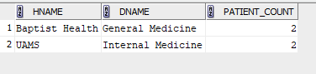  
  
*2. zip code of patient who are 18 years or younger*   
SELECT p.zip   
FROM   department_info D   
       JOIN hospital_info H   
         ON D.hid = H.hid   
       JOIN patient_info P   
         ON D.dcode = P.dcode   
WHERE  p.birthdate < sysdate - ( 18 * 365 )

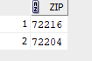  
  
*3. Patients with 'Joint Pain' Symptoms*   
SELECT P.pid,   
       P.pfname,   
       P.plname,   
       R.symptoms   
FROM   patient_info P   
       JOIN patient_record R   
         ON P.pid = R.pid   
WHERE  R.symptoms LIKE 'Joint Pain'

  
  
*4.Update Last name to 'TESTPATIENT' for patients with First Name 'TEST’*  
UPDATE patient_info   
SET    plname = 'TESTPATIENT'   
WHERE  pfname = 'Test';

   
  
*5. List all the Department for all the hospitals sorted by Hospital and Department*   
SELECT H.hname,   
       D.dname   
FROM   department_info D   
       JOIN hospital_info H   
         ON D.hid = H.hid   
ORDER  BY H.hname,   
          D.dname

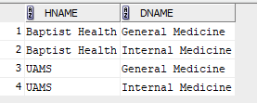  
  
*6. List all the visit information related to 'Pediatrician' Specialty*   
SELECT R.visitid,   
       R.disease,   
       R.symptoms,   
       R.diagnosis,   
       R.drugs,   
       R.patienthistory,   
       R.admissiondate,   
       R.dischargedate,   
       P.specialty   
FROM   patient_record R   
       JOIN physician_info P   
         ON P.physician_id = R.physician_id   
WHERE  P.specialty LIKE 'Peditrician'   


*7. Hospitals with 'Internal Medicine' Department*   
SELECT DISTINCT H.hname   
FROM   hospital_info H   
       JOIN department_info D   
         ON D.hid = H.hid   
WHERE  D.dname LIKE 'Internal Medicine'

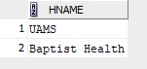  
  
*8. Patient Visit by Gender*   
SELECT p.sex,   
       *Count*(*) visits   
FROM   patient_record v   
       JOIN patient_info P   
         ON v.pid = P.pid   
GROUP  BY p.sex

